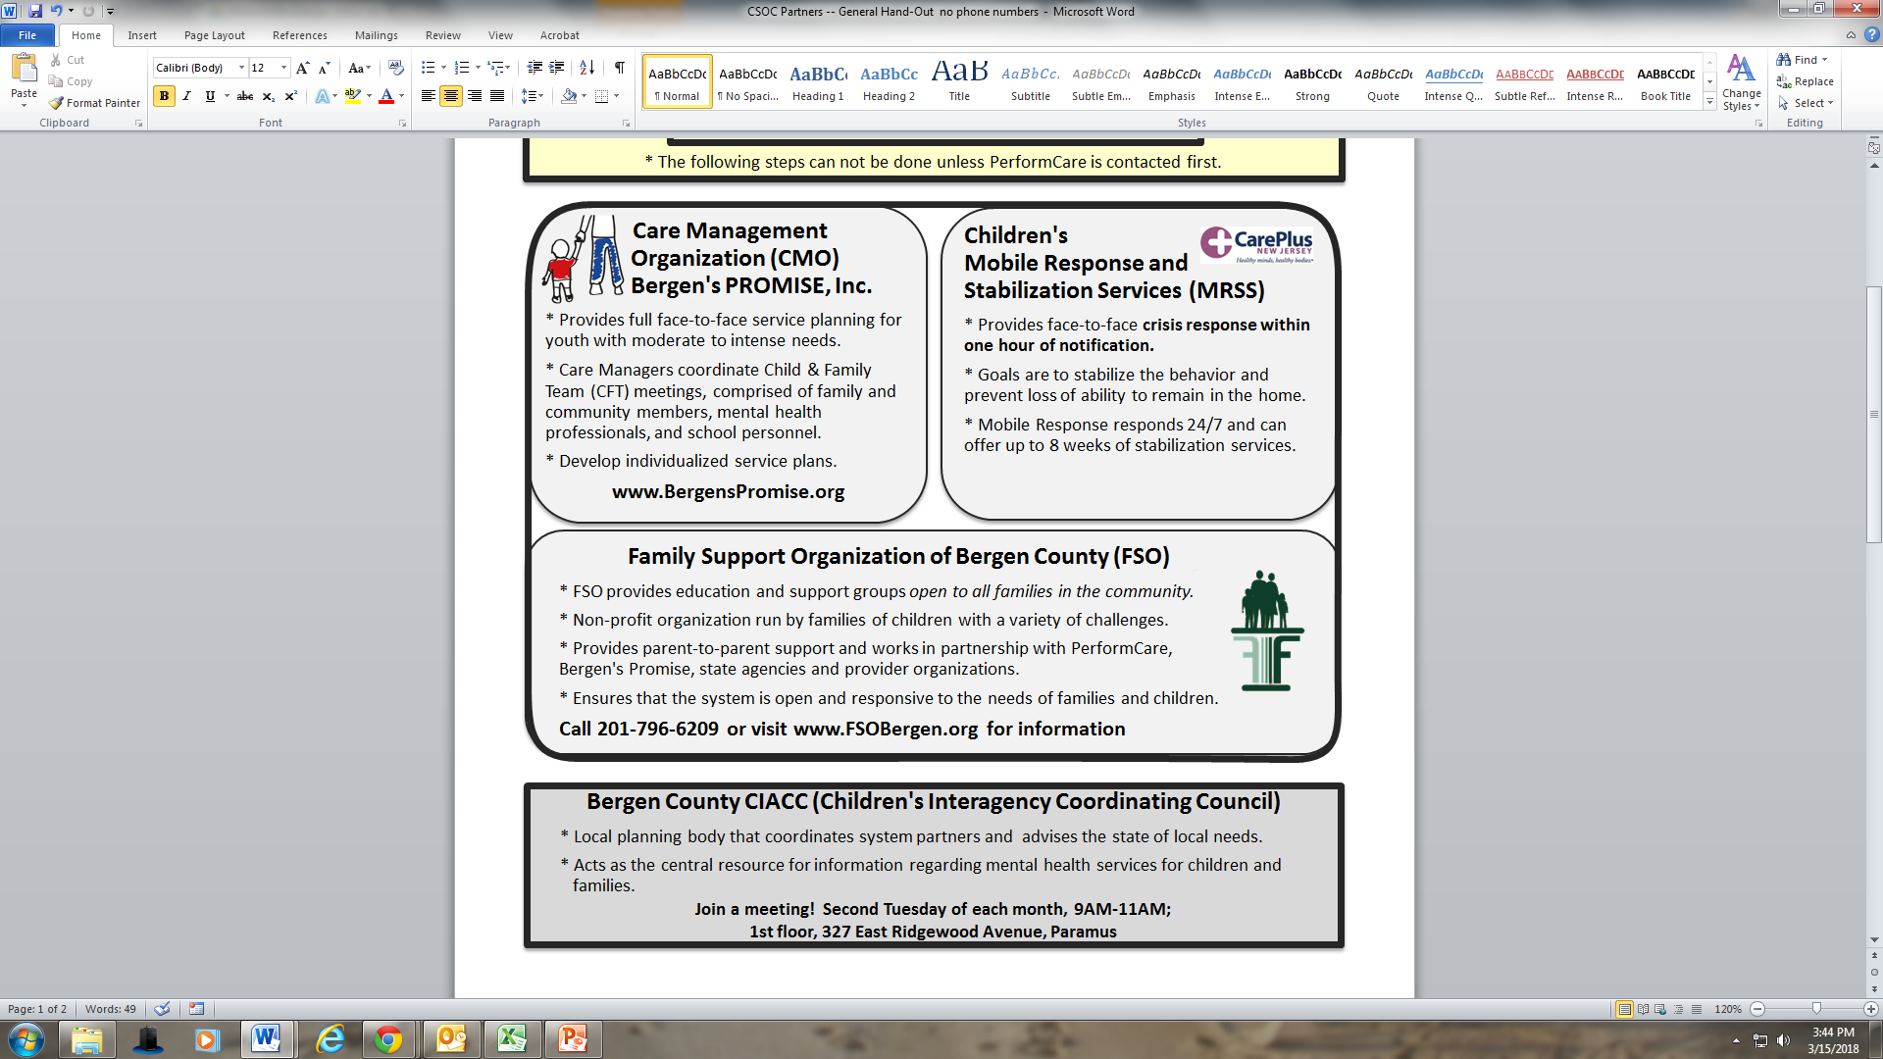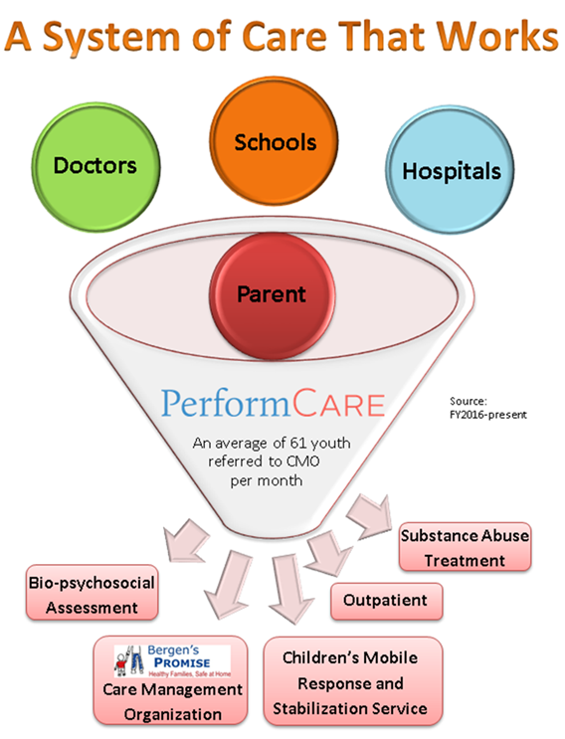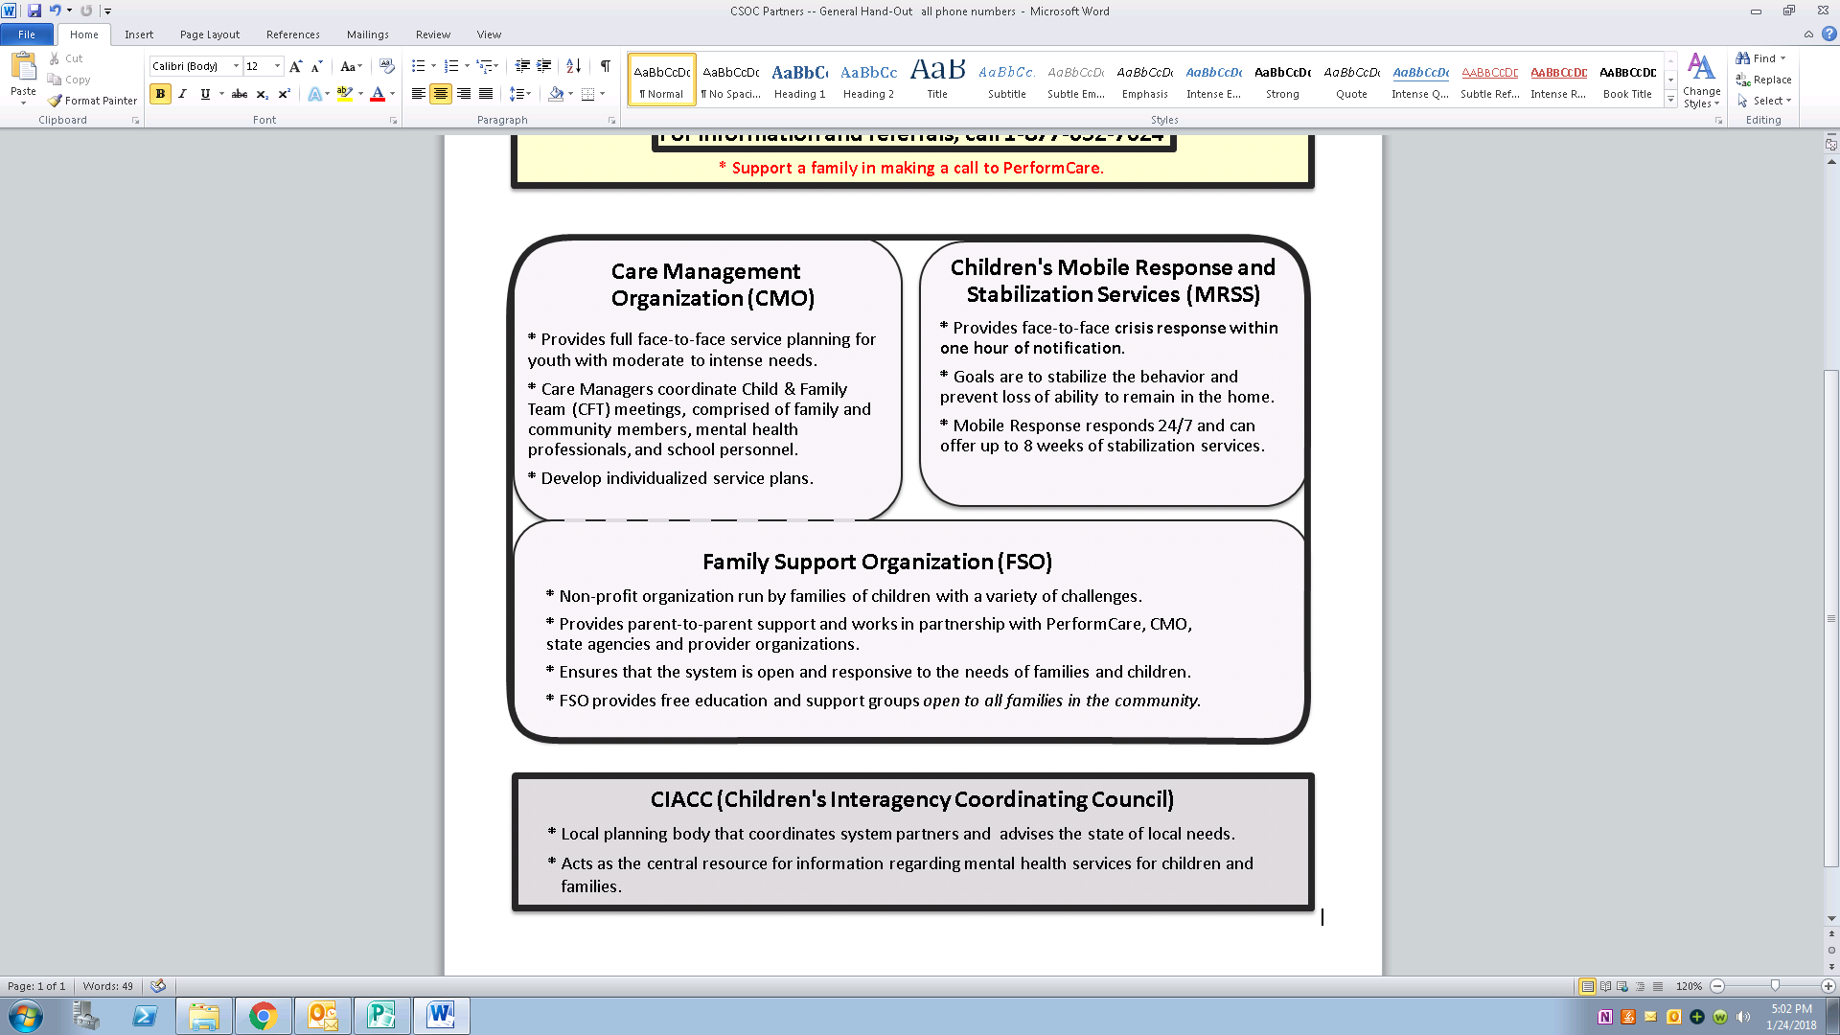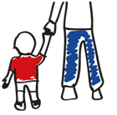

**NJ Children’s System of Care**

**Referral Process**

The Children’s System of Care (CSOC) helps youth up to age 21 with emotional, behavioral, developmental, substance and related health challenges. CSOC wraps services and supports that families need in a home and community-based, family-centered environment at no cost to families regardless of income or insurance.

***How can YOU assist a family with making the call to PerformCare to access services?*1-877-652-7624**

**The System Partners in Bergen County**

